**Importing acadgild_spark vm using Oracle vm**

**Steps that followed to import acadgild vm:**

1.Open the virtual box and then follow the below steps:

**Click on File --→ Import Appliance.**

2. **Click on the Folder option as shown in the below screenshot to browse to the location where hadoop vm is present.**

* **Select the VM to be imported an then click on Open button.**
* **Click on Next to proceed to next step:**

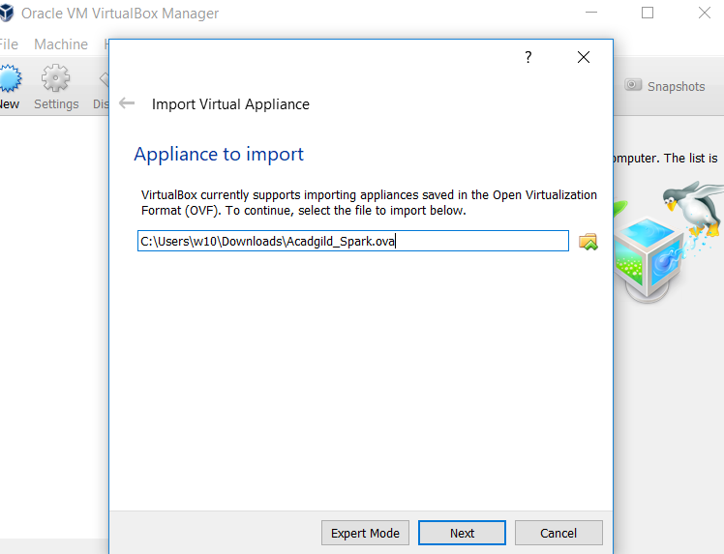

**5. Click on import button to start importing the acadgild VM.**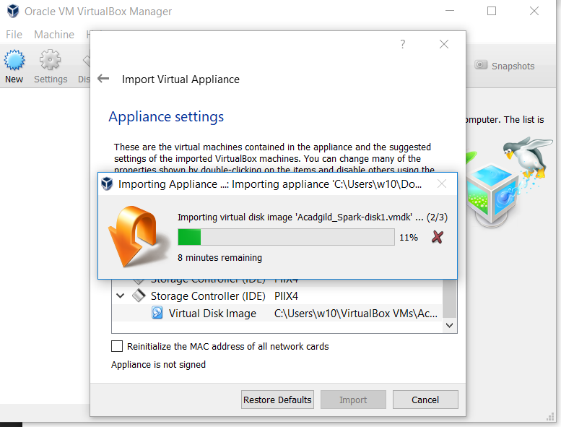

**Once the importing gets finished, we need to click on the start button**

**8. We need to give the password as acadgild.**

**Password: acadgild**

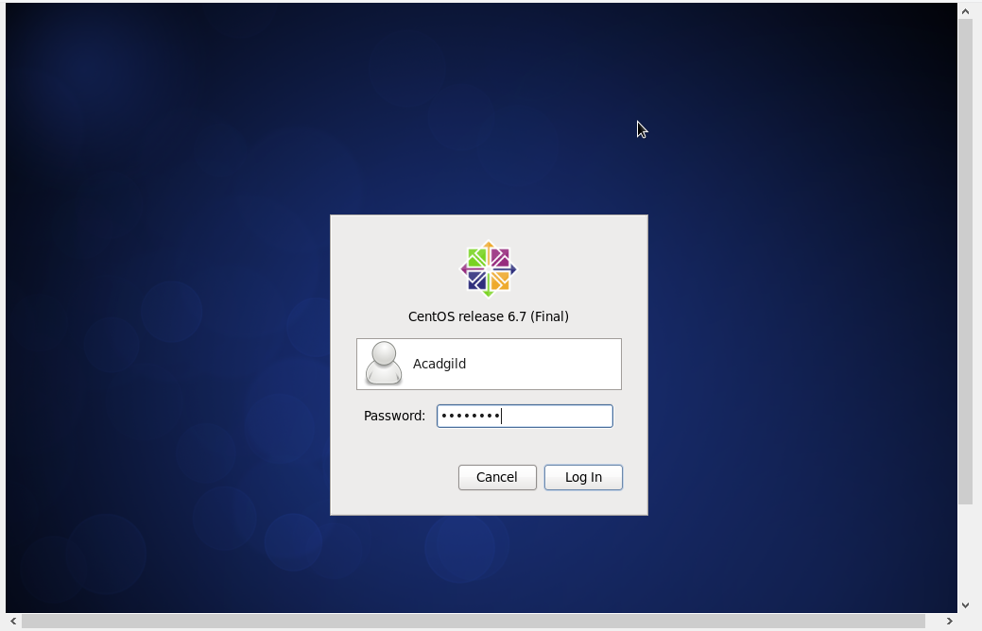

**9. Open the terminal and type the command jps to check the list of daemons, we need to start all the daemons for the first time.**

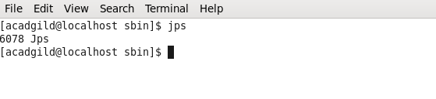

**Starting Hadoop daemons**

# Starting NameNode, DataNode, ResourceManager, NodeManager and Jobhistoryserver

**NOTE: Change the directory to sbin of hadoop before starting the daemon.**

## In the VM hadoop-2.6.0 is present in /user/local directory

**Command: $ cd hadoop-2.6.0**

**$ cd sbin**

**Starting namenode:**

**Command: ./hadoop-daemon.sh start namenode**

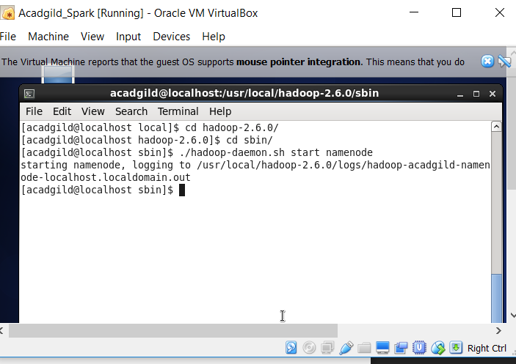

**Starting datanode:**

**Command: ./hadoop-daemon.sh start datanode**

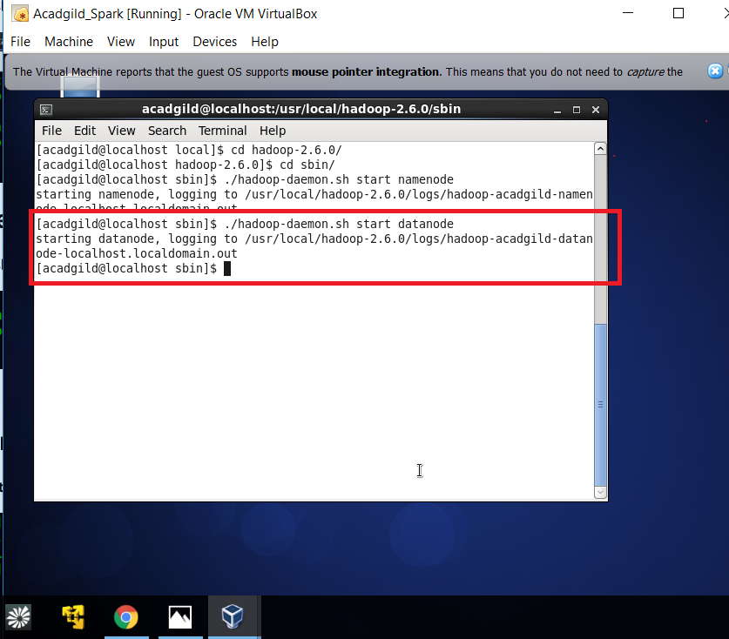

**Starting resourcemanager:**

**Command: ./yarn-daemon.sh start resourcemanager**

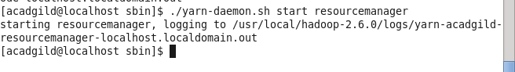

**Starting nodemanager:**

**Command: ./yarn-daemon.sh start resourcemanager**

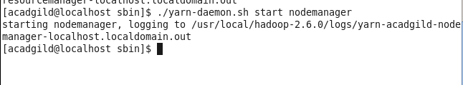

**Type the command jps to check the health of the daemons, if all the daemons will be running then cluster is ready.**

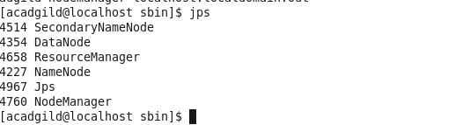

**To Stop all the Running daemons type the command *./stop-all.sh***

**11.Starting Spark daemons Master,Workers**

Move into the sbin folder of spark installed directory(Here spark is installed in /usr/local/spark/ directory.)

**Starting Master:**

**Command: ./ start-master.sh**

**Starting Slaves:**

**Command: ./start-slaves.sh**

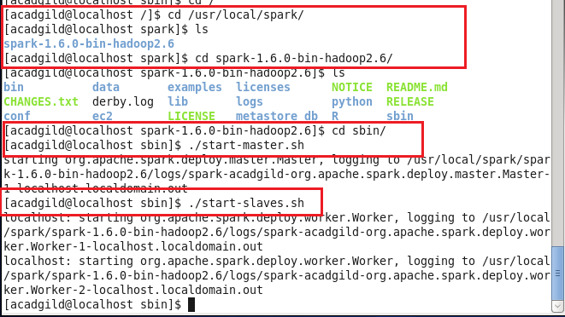

**Now you can type the jps command to check the Master and Slave daemons running.**

**All the Hadoop and Spark daemons are Running Successfully.**

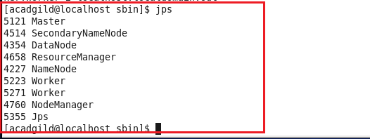

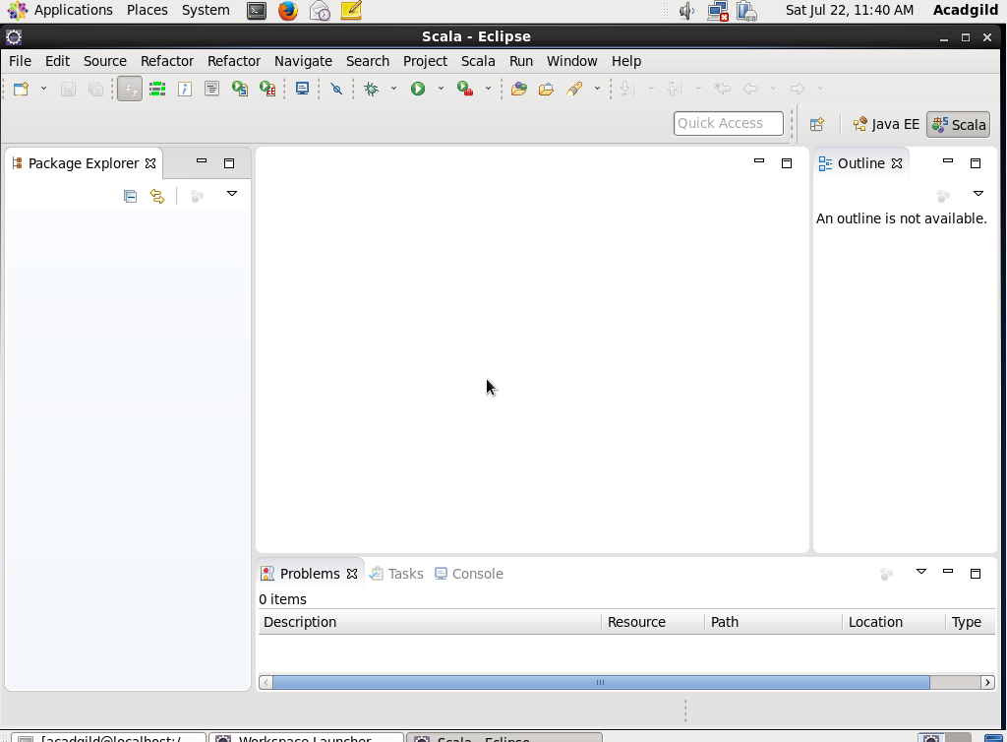**Working on Eclipse in Acadgild VM:**

To Open Eclipse, Double click on the **Link to eclipse** icon on the Desktop.